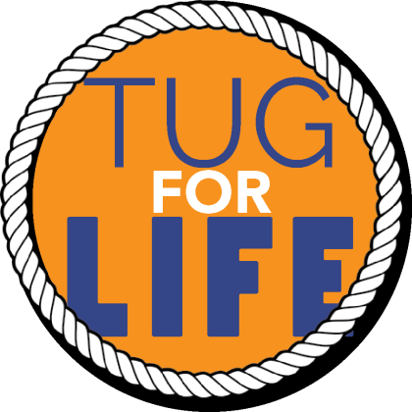
October 3, 2016
Dear Name
Name of School is participating in the Tug For Life school program and fundraiser to help neglected and abused children in Texas. I am writing to you in hopes that you will please make a donation to support our school in this fundraising event. This event brings together the importance of physical fitness and emotional strength while integrating desired Character Traits to motivate and model at our school.
Boys & Girls Harbor is a 501(c)(3) nonprofit general residential facility licensed by the Texas Department of Family and Protective Services. The Harbor provides underserved, neglected and abused children in our community with shelter, food, clothing, education, counseling, health care, recreation, and most importantly, a stable family environment.
Please let me know if we can count on your support so we can credit your sponsorship/donation to our school and recognize you on social media and local media opportunities as our sponsor.
Warm Regards,
Your name, title/school and contact information
Boys & Girls Harbor Contact: Mary Baumann Director of Corporate and Community Relations 8200 Washington Ave. , Suite 120 Houston, TX 77007 Mbaumann@Boysandgirlsharbor.org WK: 713 688-6262 X 303
Follow us on Facebook at https://www.facebook.com/BoysandGirlsHarbor/ to keep updated on the competition and attend the final Tug-off in December!

